System Proposal

INFO 361 - 901

Trilogy Association

**Table of Contents**

Project Description………………………………………………………………………..Pg. 3

Original Systems Request………………………………………………………………...Pg. 4

Business Case…………………………………………………………………………….Pg. 5-6

Cost/Benefit Analysis…………………………………………………………………….Pg. 7

Work Plan/Gantt Chart……………………………………………………………………Pg. 8

Requirements Definition…………………………………………………………………Pg. 9

Use Cases………………………………………………………………………………...Pg. 10-18

Data Flow Diagrams…………………………………………………………………..…Pg. 19-21

Entity Relationship Diagram……………………………………………………………..Pg. 22

User Interface Prototypes………………………………………………………………...Pg. 23

Usability Test Report……………………………………………………………………..Pg. 24

Executive Summary………………………………………………………………………Pg. 25

**Project Description**

This business proposal will be for a young woman named Jasmine Stokes whose business focuses on art. She recently decided to acquire a gallery with a small performance space in the Richmond Arts District to be able to promote both new and established artists. The purpose of this information system is to be able to recreate the gallery/performance to make it work in a virtual environment and manage auction and employee schedules to support both online and on premise operations.

The requirements for this information system should include the following:

* Being able to manage work requests and events
* Able to keep track of the inventory
* Keep track of business contacts and customers
* Manage work requests and events
* Manage advertising and web presence
* Establish a way to present exhibits/ performances virtually

The purpose of this project is to develop an information system for Stokes Gallery. The system will be able to hold events that can be both virtual and in person. The system itself will include the database, keeping track of inventory, business contacts and customers, managing web presence, and finally, managing work requests and events. This project should also allow Jasmine to not only expand her business and improve her gallery’s online presence, but it’s also so that she could give better support for her business and the artists that she’s representing.

**Original Systems Request**

Project Name: Stokes Gallery Information System; Project Sponsor: Jasmine Stokes, owner

Local art lover and entrepreneur, Jasmine Stokes, recently established a gallery with a small performance space in the Richmond Arts District to promote both new and established artists from the area. She started her business a few years ago by hiring a few part time employees so she could still attend art fairs and private auctions to build her collection as well as discover new talent and found herself quickly overwhelmed trying to juggle everything. After an initial period of struggling to learn about the business and trying to make a profit, things were just beginning to fall into place as the pandemic shut everything down. Since then, she has had some success pivoting online by utilizing alternative ways to engage her clientele (e.g. virtual exhibits and performances, online auctions, etc). As she plans to start slowly opening the gallery back up to the public, she has determined that a suitable information system would allow her to better support both her business and the artists she represents. Jasmine had taken some information system courses in college and realized that she could potentially expand her business and improve the gallery’s online presence by taking advantage of some of the newer technologies available. She has asked your team to help develop a system to meet her business needs.

Business Need: Recreate gallery/performance experience virtually, manage auction and employee schedules to support both online and on premises operations, transaction processing, financials and accounting, keep track of business contacts (artists, dealers) and clientele (for marketing/donor support).

Functionality: Facilitate and manage the business operations in order to:

* Schedule and manage work requests/events
* Establish a way to present exhibits/performances virtually
* Manage employees
* Manage purchases and sales transactions
* Manage and generate business reports
* Keep track of inventor
* Keep track of business contacts and customers
* Manage advertising/web presence
* Take advantage of newer technologies

Business Value: Improve engagement/analytics to increase revenue, increase customer base**,** improve efficiencies and maintain good relations with contacts and clientele

Special Issues and Constraints:

* Just purchased a laptop computer with an external HD webcam
* Currently uses only Microsoft Office software (Word, Excel)
* Knowledgeable about the internet and teleconferencing services
* Has both a Facebook and Instagram account for the business and knows that many of her customers use the most popular social media apps

**Business Case**

Statement of purpose or business needs: Recreate gallery/performance experience virtually, manage auction and employee schedules to **support both online and on premises operations**, transaction processing, financials and accounting, keep track of business contacts (artists, dealers) and clientele (for marketing/donor support).

Business value:Improve engagement/analytics to increase revenue, increase customer base**,** improve efficiencies and maintain good relations with contacts and clientele.

Scope statement:There are at least 9 different functional requirements that are required for this project. Out of all the functional requirements that are listed, the ones that would be considered part of the major business needs and functionally are scheduling and managing work requests/events, managing advertising/web presence, and finally taking advantage of newer technologies. For scheduling and managing work requests and events, it's important to make a schedule for all the work requests and make sure they are up to date because if they are not, then things can get out of hand. For advertising/web presence, it’s important to constantly advertise your work so that more people would know about it and even become interested. Finally, for taking advantage of newer technologies, it’s important to keep up to date with the latest technologies because it will be easier to adapt to newer generations.

Technical feasibility study:There are at least 4 tech issues. For the first tech issue, it’s going to be difficult using only Word and Excel since there’s a good chance a client would want something not made in Word or Excel. For the next tech issue, I think that only using Facebook and Instagram for her work isn’t good enough since there are a lot of different social media platforms to keep up with. Her third technical challenge is that she admits to not only getting a new laptop but also an external HD webcam. Instead of the webcam, she could have gotten something to benefit her business. Her final technical challenge is having some knowledge of the internet and teleconferencing services. While it’s good to know about those, it’s good to have more knowledge about other things like marketing and economics.

Economic feasibility study:From my business perspective, Jasmine has already begun making profits out of this. She has already gone past her break even point, and has already generated a net profit of $1,751 in just her first year. I think from a business perspective it makes tremendous sense, and as you can see her profits grew even more after the covid spread had died down. As you can see from the charts after her 5th year she has a net benefit worth up to $145,838. Additionally, her ROI is about 30% therefore she is looking good, because around 30% is an ideal range for a business. Let’s move on, and address the NPV. With having a very positive and NPV at around $115,833.77 as well as a discounted rate on investments at around 4%. This means if you have higher discount rates, you just need to pay more debt that we have. Not only with the Covid vaccine fully out, but as well as more comfortability to engage and meet with people in person I think that it is reasonable to expect about a 40% profit over the next few years. Therefore, from a business perspective I think it makes a lot of sense and I definitely think that this business will create a lot of profit in the future.

Can the business afford it?As I mentioned previously, the company is expected to be above the break even point moving forward. We need to keep in mind that for most companies, it can take over two years to get past that break even point, but we need to understand that Jasmine has already done this within her first year. This shows the direction that Jasmine is moving in as a company and it is looking very positive. So to answer the question, yes Jasmine can most definitely afford to run the business, as the net profits are expected to increase and her costs will continue to remain about the same.

Risks: We can consider that Jasmine's business is low risk while also taking into consideration these factors. Considering the cost benefit analysis does not include; inflation, interest rates, and present money. One of the greatest risks we can take into consideration is if another Covid like situation were to happen. If this were to happen, it would be a devastating situation but Jasmine does have the option to move to a virtual work. If we go on ahead and divide net benefits by her total costs we will see an ROI of around 28%. Additionally, The NPV is a high number at around $115,833.77 at a discount rate of around 4% Therefore, it is safe to assume that this will be profitable and low risk.

Organizational feasibility study:Addressing the functionality factors associated with this project allows the project to be better aligned with Jasmine’s business. Strategic alignment between the project and business is crucial to ensuring the system will be accepted by its users and that it can be incorporated into ongoing operations. Alignment between the business management team, system users, and other stakeholders is carried out by communicating the functional aspects of the project including improving engagement, increasing customer base, improving efficiencies, and maintaining good relations. This helps convey the importance of these functionalities among other decision makers. Conducting stakeholder analysis is a strategy that can be implemented to further increase strategic alignment between the project and business as well.

**Cost/Benefit Analysis**

|  |  |
| --- | --- |
|  | **Work Plan/Gantt Chart**  Our team has consistently communicated our project management plan, and we utilized a Gantt chart to view our intended deliverables and their requirements more easily. The horizontal axis includes the dates our team projected to have our deliverables complete by. The vertical axis lists specific task requirements as well as the team member responsible for each role.  Along with our system proposal, our complete Gantt chart will also be submitted through Canvas as well. This will allow you to better view and understand the process our team carried out over the course of this project. |
|  | **Requirements Definition**  Functional Requirements:   * Process-Oriented   + The system must be able to manage work requests and events.   + The system must be able to keep track of the inventory.   + The system must be able to keep track of business contacts and customers. * Information Oriented   + The system must be able to manage advertising and web presence.   + The system must be able to manage business reports.   + The system must establish a way to present exhibits/performances virtually.   Non-functional Requirements:   * Performance and scalability. How fast does the system return results? How much will this performance change with higher workloads? * Portability and compatibility. Which hardware, operating systems, browsers, and their versions does the software run on? Does it conflict with other applications and processes within these environments? * Reliability, availability, maintainability. How often does the system experience critical failures? and how much time is available to users against downtimes? * Security. How are the system and its data protected against attacks? * Localization. Does the system match local specifics? * Usability. How easy is it for a customer to use the system? |
|  | **Use Cases** |
|  | **Causal Use Case #1**   |  |  |  | | --- | --- | --- | | **User Case Name:** Tracking Business Contacts & Customers | **ID:** UC-1 | **Priority**: High | | **Actor:** Employee (data analyst/tracker) | | | | **Description:** Information system includes a database to track business contacts and customers. | | | | **Trigger:** The need for marketing and donor support. | | | | **Type:** Internal | | | | **Preconditions:**   1. The tracking database is an online system. 2. Each contact/customer has provided contact information which is documented in a designated database system. 3. The system displays two categories of contact information. One category consists of business contacts while the other displays customer contact information. | | | | **Normal Course:**   1. The employee opens the tracking system to access contact information. 2. The employee determines which category of information (either customer contacts or business contacts) suits their needs best (marketing outreach or donor support). 3. The system provides both primary and secondary means of contact. 4. The employee determines which contacts to communicate with. 5. The employee reaches out to designated contacts.    1. If contacts are reached, communicate the purpose of contact.    2. If contacts are not reached, note to reach out to their secondary means of contact. 6. The system documents which contacts have been reached/missed and when the call took place. | | | | **Postconditions:**   1. Confirmed contacts will be displayed as accepted. 2. Unconfirmed contacts will be displayed as not reached. 3. The employee understands which business and customer contacts are active or inactive. | | | | **Alternative/Exceptional Flows:**   1. Employees will remove contacts that have remained inactive for longer than a year. 2. Employees will continue to add contacts into the tracking system as they are identified. | | |   **Causal Use Case #2**   |  |  |  | | --- | --- | --- | | User Case Name: Manage and Generate Business Reports | ID: UC-2 | Priority: High | | Actor: Worker | | | | Description: Information system to include managing and generating business reports | | | | Trigger: Worker Wants | | | | Type: External | | | | Preconditions:   1. The worker is generating business reports 2. The worker would then manage those business reports. | | | | Normal Course:   1. The employee slowly begins to generate business reports. 2. After a certain amount of time, the employee will start to manage those reports 3. If needed, more business reports would be generated and later, managed. | | | | Postconditions:   1. Any business reports that are free of errors and/or have everything needed may end up being published 2. Any business reports that have any errors and/or not have everything needed will end up continuing to be managed until it’s ready to be published. | | | | Alternative/Exceptional Flows:   1. All workers would go and manage all the business reports that were generated by other workers. 2. All workers would add anything that happens to be missing from the business reports. | | |   **Causal Use Case #3**   |  |  |  | | --- | --- | --- | | User Case Name: Upgrades to Business | ID: UC-3 | Priority:High | | Actor:Manager | | | | Description: The owner of a business has approved plans to get various upgrades to different technological devices within the company | | | | Trigger: New requirements require improved technology that the business may not have as it may be outdated | | | | Type:External | | | | Preconditions: 1.The owner of the business logs in to his account  2.The owner receives confirmation of the upgrades that have been ordered  3.The third-party company is processing and getting your order prepared | | | | Normal Course:  1.The manager receive shipments of the technological upgrade he orders  2.The items correctly display the order details  3.The manager confirms the software in each item is the same and configured  4.All technological items are now configured and up-to-date with the system  5.The manager now approves any tasks that require the new technology that is acquired  6.The company begins doing more orders with this new improve tech | | | | Postconditions: 1.New technology is no longer required and the manager cancels the order  2A note is sent out to the third-party company that provided the technology to cancel the order,  the resource management department within the company is notified about this | | | | Alternative/Exceptional Flows:  1.The technology acquired from the third-party company does not have the up-to-date software required for this company  2.The manager gets notified of this and sends a message to the third-party company  3.Through communication they send back the devices they do not work, and are sent with replacements that are up-to-date  4.The technology all is now up and running with no issues | | |   **Fully Dressed Use Case #1**   |  |  |  | | --- | --- | --- | | User Case Name: Manage scheduling/employees | ID: UC-7 | Priority: High | | Actor: Scheduler | | | | Description: Another worker is focusing on managing both scheduling and the employees | | | | Trigger: There would be several workers that would be doing tasks, so the manager has to keep up to date with all those tasks. | | | | Type: External | | | | Preconditions:   1. The manager would start managing the schedule 2. The manager would manage the employees. | | | | Normal Course:   1. The manager starts by creating a schedule. 2. The manager would then choose different employees to fill the tasks. 3. The employees would be given a day and time where they have to work on a specific task. 4. Employees will have a certain amount of time to get that task done, and then the manager would update the schedule. | | | | Postconditions:   1. Any delays would cause the manager to push back certain times in the schedule. 2. Any changes would also cause the manager to change how the schedule is already set up, which would mean that dates may be pushed back. | | | | Alternative/Exceptional Flows:   1. The manager must continuously update both the schedule and the employees. 2. The employees must be able to get everything done so that the manager could keep the schedule up to date. | | | | Summary Inputs:   * Schedule * Assign tasks * Assign dates * Tasks being worked on | | | | Source:   * Manager * Manager * Manager * Employee | | | | Summary Outputs:   * Updates to the schedule * Number of tasks completed * Number of tasks that’s been finished within the timeframe. * If all work has been completed or if there’s any remaining work that has yet to be completed. | | | | Destination:   * Manager * Manager * Employee * Employee | | |   **Fully Dressed Use Case #2**   |  |  |  | | --- | --- | --- | | User Case Name: Managing Advertisements | ID:UC-7 | Priority:High | | Actor:Web Developer | | | | Description:The manager is planning on developing a new program that can actively manage advertisements and choose which ones are valuable to the company and which ones aren’t. | | | | Trigger:  A lack in publicity of the company and more need to reach out to other big companies for ads. | | | | Type:External | | | | Preconditions:  1.The web developer within the company receives a request from the manager to create a program that sort out bigger companies from smaller companies that run their ads  2.The web developer than approves this request and gets started in coding this new program | | | | Normal Course:  1.The web developer approves the request given to him by the manager that outlines a set of requirements that he wants for this new program  2.The web developer begins developing this program and follows the requirements given to him by the manager  3.Once the program is fully developed, it is tested with the ads that are already run by this company  4.If correctly developed, the website should be able to accurately sort out big companies from small companies and remove ads from small companies  5.This program friend helps this company generate more profit by only running ads from bigger companies and devoting more focus on to just them | | | | Postconditions: 1.From now on every time this company receives request for ads, it runs them through this new software that has been developed  2.Big ads will remain in the system, and the company can then devote more time to developing those ads, where as the small ads will be completely removed from the software, and will notify the company that they no longer want to run ads/ | | | | Alternative/Exceptional Flows:  1.The program will automatically keep a small companies add if the profit margin is similar to what they would receive from the big ads.  2.This is a feature automatically programmed into the software by the company's web developer.  3.If the program cannot accurately calculates which ads are from big or small companies, the web developer will reboot the program.  Summary Inputs:Collection of ads run by the company, number of ads that are from small companies, number of ads that are from big companies | | | | Source: Web Developer, Web Developer, Web Developer, Company | | | | Summary Output:Number of ads that need to be thrown away from small companies, number of ads that need to be kept from big companies, as well as the number of ads from small companies that generate high revenue | | | | Destination: Manager, Web Developer, Web Developer, Manager, Manager | | | |

**Data Flow Diagrams**

Context Diagram:

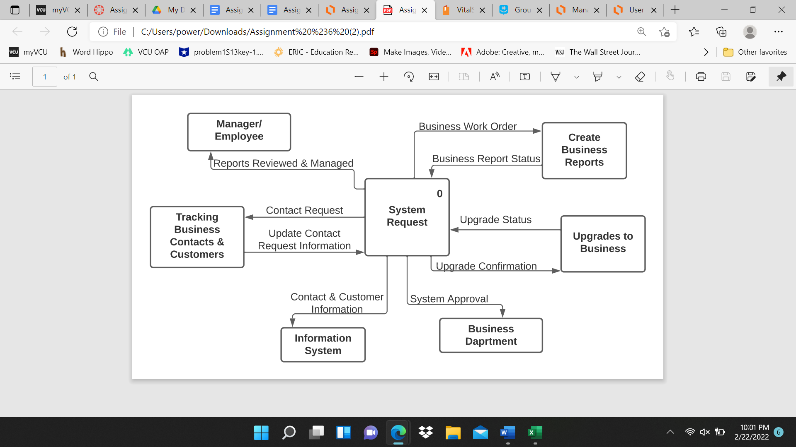

Data Flow Fragments:

* Data Flow Fragment #1:

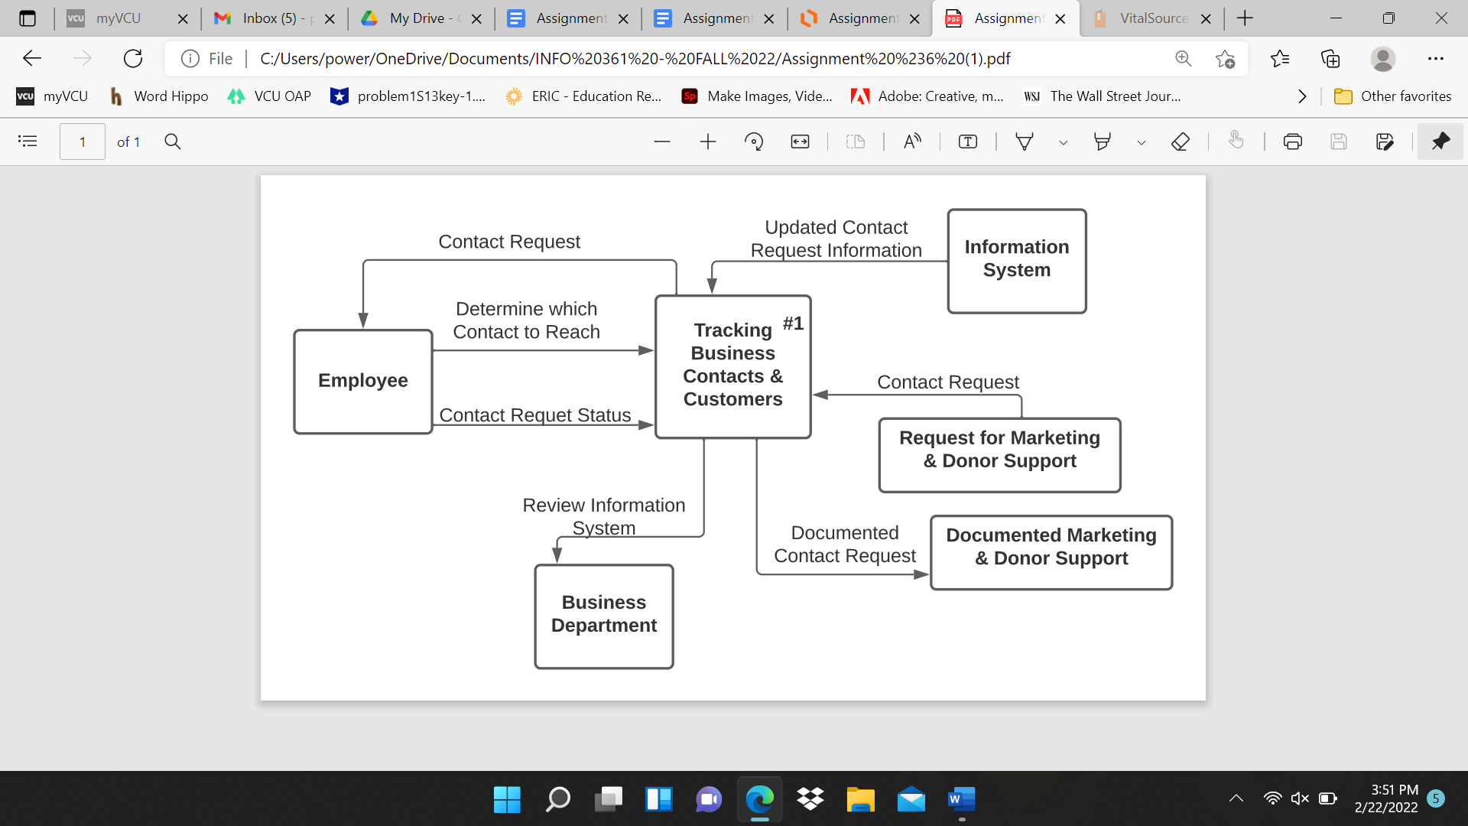

* Data Flow Fragment #2:

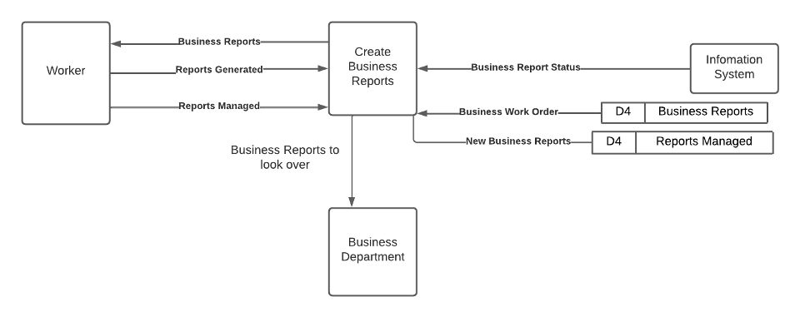

* Data Flow Fragment #3:

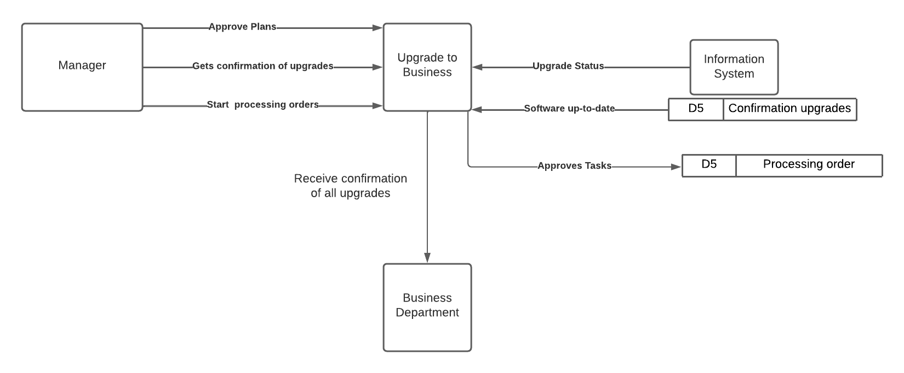

Level 0 DFD:

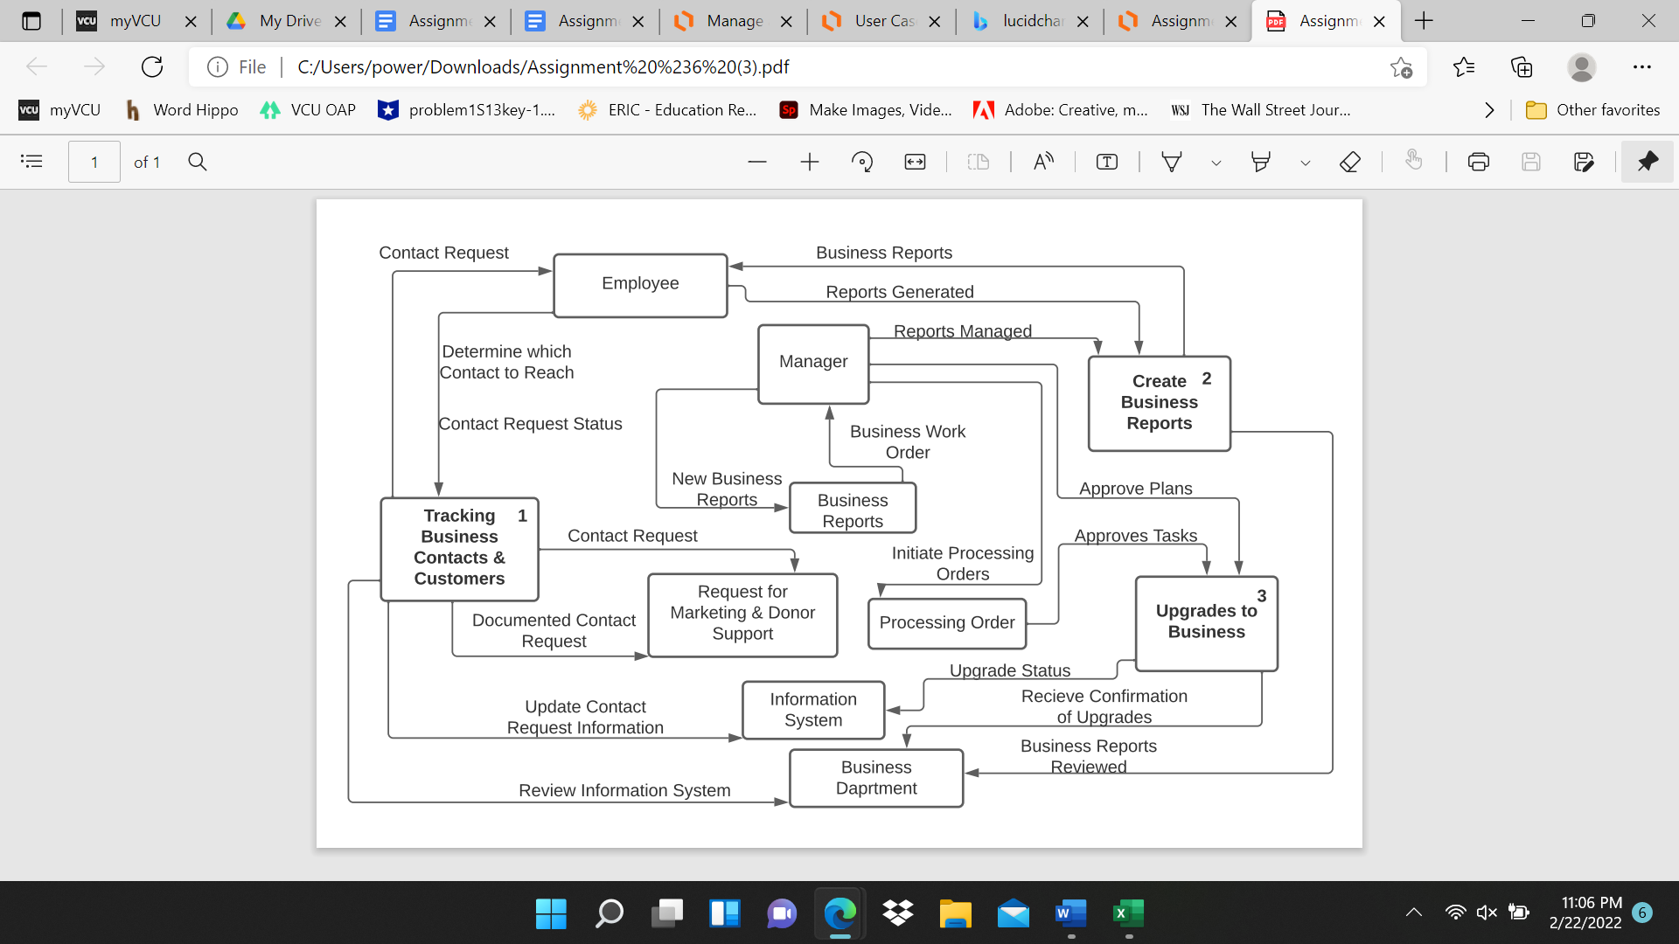

**Entity Relationship Diagram (ERD)**

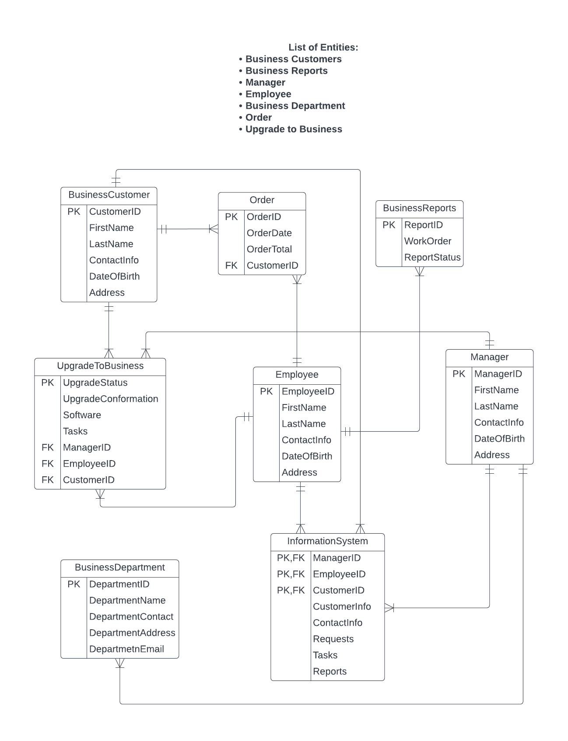

**User Interface Prototype**

Interface Design Prototyping (Wireframe Diagram):

|  |  |  |  |  |  |  |
| --- | --- | --- | --- | --- | --- | --- |
| System Request | | | **Account Sign-In** | | **Social Media links** | |
|
| **Search Box** | | | **Create Account** | | **Cart** | |
|
| Tracking Business | Creating Business | Upgrade To | Business | Information | Order | Processing |
| Contacts and Customers | Reports | Business | Department | System | Placements | Orders |
| Features | | **Content:** | | | **Quick Links:** | |
| Business Reports | | View our Generated and Managed Business Reports | | | Calendar | |
| Contact Request | | View all out Business Contacts | | | Account Information | |
| Approved Plans | | Make a request for Marketing and/or Donor Support | | | Settings | |
| Business Work Orders | | Check out our Business Department | | | About Us | |
| Check out all of our current and past Business Work Orders | | | **Live Chat With Someone From Our Team** | |
| Approved Tasks | |
| Our up-to-date software | | | **Contact Us:** | |
| Confirmation for Upgrades | | - click to access email address and phone | |
| Review our Information System | | | - Click to Meet our Team | |
| **Trilogy Association (Main Content Categories)** | | | | | | |
|

**Usability Test Report**

Walk‐Through Evaluation:

The prototype for our user interface is a fairly simple interface, yet complex in terms of the number of options and services provided within our interface. For someone who is not very advanced technologically, or has trouble finding certain things, our usability testing experience was very positive in regards to accessibility for our users. Our user interface is actually very simple to use, our opening screen has everything that you need to access. In the middle of our screen we have the main content of our business. These are the main features, and they are easily accessible right in the middle of the screen. To the left of that we have a column of other informant information Including contact request, approved plans, business work orders, approved tasks, and confirmation for upgrades. On the right includes quick links that are relevant to our company but aren't very important. Nevertheless, this is important information a user may want access to, this includes; calendars, account information, settings, and additional information about our company. On the bottom right as many companies do, we have quick access to contacting us, as well as an option for live support from someone on our team. Other than that everything else is very easily accessible as you can create your account on the top, sign in, and search for whatever you need. Our usability testing experience was tested by my roommate, who is a psychology major and does not have much of a technological background. He was asked to complete a series of tasks in which he was easily able to do and easily navigate through the website and look for whatever he needed. Although my roommate was the main subject for the test, we had various other people check out the website, and give their feedback on the user interface. We found that almost 100% of the people found the website to have a very user-friendly interface, that is easily able to be navigated through. Because of this very high and positive feedback in terms of our user interface, we have found that no current changes will be needed in the near future in terms of our interface. We will continue to make improvements on our current interface, however as we currently stand we have a very friendly user interface.

**Executive Summary**

In this system proposal we have a lot of things included. To begin we have the table of contents where we can find various pieces of information. Next we have the project description. This includes our business proposal as well as various requirements within our proposal. After that we have the original systems request. This includes our business needs as well as things that need to be improved upon as well as special issues and constraints. After this we have our business case study. This is content, published by us that outlines our success and effectiveness in dealing with clients. After this we have our data flow diagrams. These are diagrams and workflow or steps within our business process with a focus on the flow and transformation of business data. After this we have our user interface prototype. This is a sample of what our interface wants to look like. It is as user friendly as possible. Lastly we have our usability test code. This is more a filial version of our final prototype. This system should be ready to go and up and running.